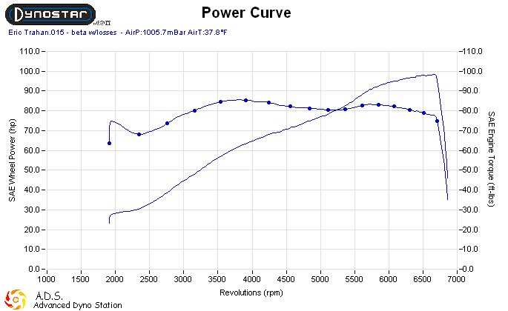
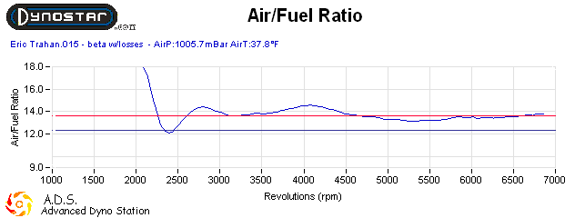

Eric Trahan – Jardne Pipe, stock cams, Stock ECM, Custom Filter, Direct Link tune on Dynostar

98.4 HP @ 6652 RPM, 86 ft-lbs. @ 3796 RPM

